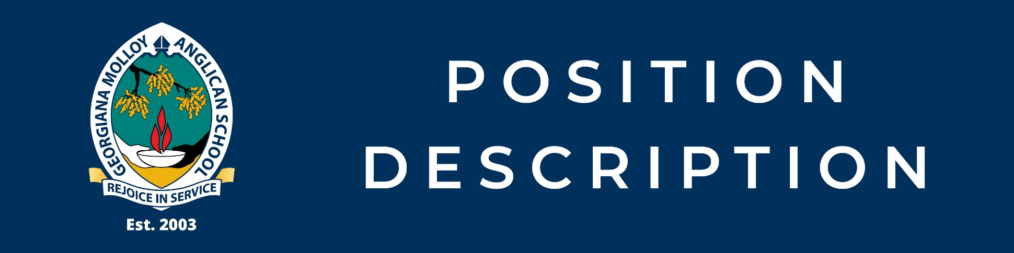
Position Title | Open Water Supervisor
Tenure | Casual
Department | Health and Physical Education
Reports To | Head of Department Health and Physical Education
EBA | Anglican Schools Commission Support Staff Enterprise Agreement 2015
Classification | WA Teachers Aides and Assistants
Date Last Reviewed | January 2026

POSITION PURPOSE

The Open Water Supervisor is responsible for the safe supervision of students during school-approved excursions, camps, or activities that involve open water environments (including beaches, rivers, lakes). The role ensures that water-based activities are conducted in accordance with school policies, Anglican Schools Commission requirements, and relevant safety and risk-management guidelines.

KEY ACOUNTABILITIES

Student Safety and Supervision
- Provide active, vigilant supervision of students participating in open water activities during school excursions and camps
- Maintain appropriate student-to-supervisor ratios as determined by the school’s risk assessment
- Identify and respond promptly to hazards, environmental changes, and emerging risks (e.g. weather, tides, currents)
- Implement emergency procedures and respond to incidents, including administering first aid or water rescue if required

Excursion and Risk Management
- Work collaboratively with teaching staff and excursion leaders to implement excursion risk management plans
- Participate in pre-excursion briefings and contribute professional advice regarding open water safety
- Ensure all activities comply with school policies, excursion approval documentation, and relevant legislative requirements
- Assist in monitoring student behaviour to ensure compliance with safety instructions

Communication and Professional Conduct
- Communicate clearly and professionally with students, staff, and external providers
- Model calm, responsible, and respectful behaviour consistent with the values of Georgiana Molloy Anglican School
- Report incidents, near misses, or safety concerns to the Excursion Coordinator or School Leadership as required

Manage Self and Professional Skills
- Comply with the GMAS Staff Code of Conduct and TRBWA Teacher-Student Professional Boundaries
- Comply with legal, regulatory, ethical, environmental and social responsibilities and requirements
- Adhere to and comply with all WHS policies and procedures and relevant legislation

Other Duties
- This position will be allocated duties, not specifically mentioned in this document, but within the capacity, qualifications and experience normally expected from persons occupying positions at this classification
- Maintain a practicing role in the teaching program and/or provide cover for teacher if urgent issues arise
- Teaching load is determined on a year-by-year basis

Reference Documents
- Mandatory Reporting Policy
- GMAS Staff Code of Conduct

Other duties as directed by the Principal and/or Deputy Principal.

This position description is intended as a guideline to illustrate the main job responsibilities. It is not intended to be an exhaustive list and may change within the scope of the role at the Principal’s discretion. Employees may also be required to undertake other reasonable duties as directed.

CORE EXPECTATIONS

- Maintain strict confidentiality with respect to the School’s business
- Display a strong dedication to customer service.
- Foster a commitment to continuous improvement and the value of collaboration and sharing of knowledge and information
- Demonstrate overt support for the School values
- Develop and maintain positive working relationships with stakeholders
- Be appraised regularly, according to the Staff Appraisal Programme in place in the school

POSITION DIMENSIONS

People Management
Nil

Budget / Expenditure:
As advised by Principal and Business Manager annually

Significant Work Relationships
Internal | External
- Principal | - Excursion providers
- Senior Leadership Team
- Administrative staff
- Teaching staff
- Students

Work Pattern
- Monday to Friday (term time only) as required

SELECTION CRITERIA

Selection Criteria

Essential
- Current recognised aquatic/open water supervision qualification (e.g. Surf Lifesaving, Bronze Medallion, or equivalent):
  - SLSA Bronze Medallion
  - SLSA Surf Rescue certificate
  - SLSWA Surf Rescue certificate
  - SLSWA Community Surf Rescue certificate
  - RLSSA School Teacher Aquatic Rescue (START) certificate
- Current First Aid qualification
- Demonstrated experience supervising children or adolescents in open water environments (preferred not essential)
- Current Working With Children Check (WA)
- Nationally Coordinated Criminal History Check
- Ability to remain calm and decisive in emergency situations
- Familiarity with local open water conditions in the South West region

Interpersonal and Work Environment Factors
The Open Water Supervisor works closely with students, teaching staff, school leadership, administrative staff, and external excursion providers in dynamic open water environments. The role requires clear, calm, and professional communication, strong collaboration skills, and the ability to maintain appropriate professional boundaries with students at all times. Work is primarily conducted outdoors in variable environmental conditions and may involve physical exertion, prolonged vigilance, and responding decisively to changing conditions or emergency situations. Flexibility is required to support excursions and camps during term time, sometimes involving extended hours or travel. A strong commitment to child safety, wellbeing, and the Anglican ethos of Georgiana Molloy Anglican School is essential.

ELIGIBILITY AND TRAINING REQUIREMENTS

- Provide a National Coordinated Criminal History Check issued no longer than 6 months prior to commencing duties
- Obtain or hold a current Working with Children Check

OUR COMMITMENT TO CHILD SAFETY AND ANGLICAN ETHOS

Georgiana Molloy Anglican School is a child safe environment. Our school actively promotes the safety and wellbeing of all students, and all school staff are expected to be committed to protecting students from abuse or harm in the school environment, in accordance with their legal obligations and in accordance with our Child Protection Policies and Staff Code of Conduct. A valid Working with Children Card and National Police Clearance are required for all employees at Georgiana Molloy Anglican School.

Georgiana Molloy Anglican School is an Anglican school and applicants should be able to demonstrate empathy with and support for the Schools Anglican Ethos.

AUTHORISATION

I hereby agree that this Position Description accurately reflects work requirements.

Principal Mr Brad Evans
Name Signature Date

Water
Supervisor Name Signature Date

Georgiana Molloy Anglican School is a child-safe environment

